**VMG Quarterly Reporting Guide**

**New Members**

**Avimark®**

Overview 3

Defining Report Codes 3

Report Code Suggestions 4

Chart of Accounts 5

Creating an Information Search 7

Revenue by AAHA/VMG Chart of Accounts 9

Total Number of Patient Visits 9

Revenue for Patients with Visits 10

Number of Active Clients 10

Active Patients (by species) - Past 24 Months 11

Quarterly New Clients 11

Quarterly Routine 12

Information Searches 12

Period Totals 13

Inventory Report 15

# Overview

Avimark treatment service revenue can be harvested utilizing the AAHA/VMG General Ledger Chart of Accounts definitions using the Report Codes feature in Avimark without disrupting your current reporting. Reports collecting only specific treatment services to match the VMG GL revenue buckets can be created by assigning a report code to each product/treatment service. These report code revenue buckets enable a secondary treatment service capture utilizing totally different revenue definitions such as in the VMG GL revenue chart of accounts.

## Defining Report Codes

The searches and reports as described on page 5 can be customized to only include specified categories with the use of Report Codes. These are user-defined number or letter characters (VMG suggests using the numeric GL VMG Report Codes in the table on “Chart of Accounts” on page 5) used for grouping performed services/products together on certain reports (Treatment Control Log, Patients by Treatments, Income by Treatment, Transaction Summary, and Sales Summary).

* Report codes are added from within **Options Maintenance** and typing the keywords Report Codes**.**

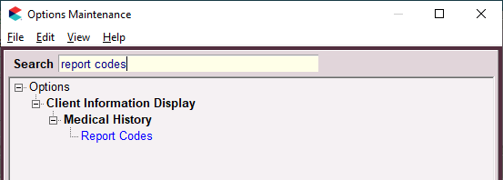

* Click on the **Report Codes** option and enter the alpha or numeric code (without spaces or commas) you would like to represent a specified category. Click **OK** when complete.

|  |  |
| --- | --- |
|  | **Enter the numbers as shown in the image that follows. The numbers will be available to combine into 3 digits to match the last 3 digits of the AAHA/VMG Chart of Accounts as shown in the table on page 5.** |

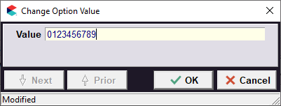

## Report Code Suggestions

Once the report codes are defined you can then assign report codes to individual treatments and items.

1. Go to **Work with > Inventory List** or **Treatments List.**
2. **Right-click > Change** on a treatment or inventory item.
3. Within the Report Codes field, click on the drop-down menu to select the appropriate report code or type in the digits. You can have up to three code values for each treatment/item. In the screen shot below, code 001 was entered as the Report Code for this vaccination.

|  |  |
| --- | --- |
|  | **You can also select all treatment/items within a category. Click Ctrl+A on your keyboard to highlight the entire list of treatments/items. Right-click > Change. Set the Report Code field, then click OK to apply the Report Code change to all highlighted treatments/items.** |

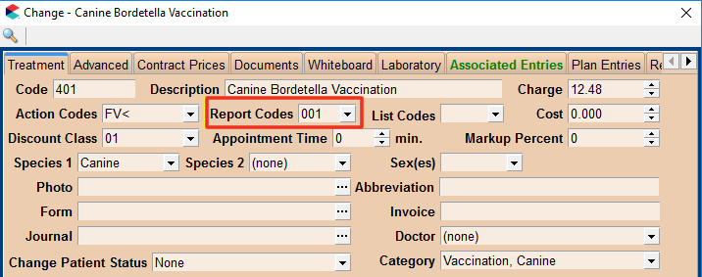

# Chart of Accounts

The following table shows the recommended 3-digit Report Code Assignment to best match the AAHA/VMG Chart of Accounts. Keep this table handy as a reference. When you run the search, Quarterly Revenue by Category, the search will return records with the 3-digit Report Codes.

You may need to identify what the VMG Category is that matches the 3-digit code.

| **Account** | **Report Code Recommendation** |
| --- | --- |
| 5001 Vaccine Revenue | 001 |
| 5010 Examination Revenue | 010 |
| 5020 Hospitalization & Treatment Revenue | 020 |
| 5025 Fluid Therapy Revenue | 025 |
| 5030 Diagnostic Services Revenue | 030 |
| 5040 Rehabilitation Revenue | 040 |
| 5045 Laser Therapy Revenue | 045 |
| 5050 Mortuary Revenue | 050 |
| 5060 Behavior Service Revenue | 060 |
| 5070 Alternative & Complimentary Medicine Revenue | 070 |
| 5080 Specialist Revenue | 080 |
| 5095 Medical Waste Revenue | 095 |
| 5099 Large Animal Svcs/Prods | 099 |
| 5105 FDA Prescription Meds, Pill, Cap, Liquid, Etc. Revenue | 105 |
| 5110 Injection Revenue | 110 |
| 5115 FDA Prescription Flea/Tick NON HW Parasite Control Products Revenue | 115 |
| 5120 FDA Prescription Combo HW/Parasite Control Product Revenue | 120 |
| 5130 Internet Pharmacy Revenue | 130 |
| 5201 Therapeutic Diet Revenue | 201 |
| 5202 Retail Diet Revenue | 202 |
| 5301 In-House Lab Revenue | 301 |
| 5302 Outside (Reference) Lab Revenue | 302 |
| 5403 X-Ray Revenue | 403 |
| 5404 Dental X-Ray Revenue | 404 |
| 5405 CT Services Revenue | 405 |
| 5410 Ultrasound Services Revenue | 410 |
| 5415 MRI Services Revenue | 415 |
| 5420 Specialist (Imaging) Consultation Revenue | 420 |
| 5510 Non-Specialist Surgery Revenue | 510 |
| 5520 Specialist Surgery Revenue | 520 |
| 5600 Anesthesia Revenue | 600 |
| 5700 Dentistry Revenue | 700 |
| 5801 OTC Prod, Shampoos, & Nutraceuticals Revenue | 801 |
| 5802 Pet Supplies Revenue | 802 |
| 5803 NON-FDA Flea and Tick Control Parasiticide Revenue | 803 |
| 5804 Internet Ancillary Sales Revenue | 804 |
| 5825 Boarding Revenue | 825 |
| 5850 Grooming Revenue | 850 |
| 5905 Fee Discounts and Client Returns | 905 |
| 5910 Returns and Allowances | 910 |

# Creating an Information Search

With the Report Codes assigned to treatments and inventory items, follow the instructions below to create and run searches to extract the data you need for VMG reporting purposes. Add the five searches that begin on page 9 by copying and pasting the red text into the Code Editor.

1. Choose **Work with > Information Search** or click on the Information Search button .
2. From within the Choose Search Criteria window, select a previously saved search or click Cancel to open a blank search window.

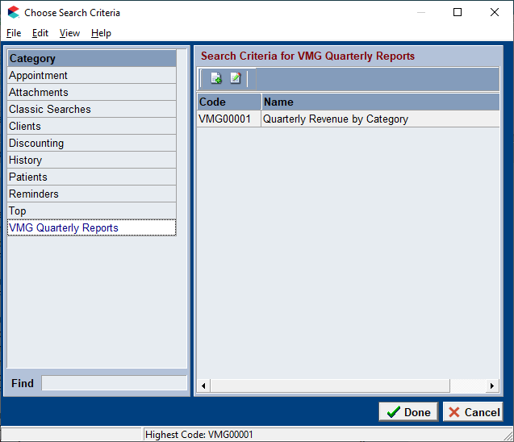

1. In the New Search Criteria window click on **View** and choose **Code Editor**.

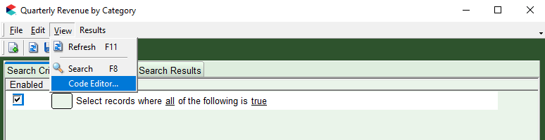

1. Press **Ctrl+A** to select the text in the Code Editor then press **Delete**.
2. Copy the code (as shown in **RED** beginning on page 9) for each topic and paste it within the Code Editor Window.

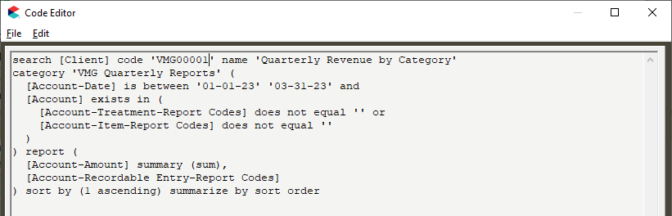

1. Click **OK** to create the search.
2. Click **Yes** to make sure you save the search for future use.

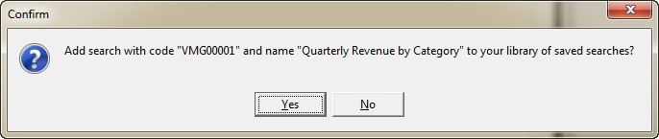

|  |  |
| --- | --- |
|  | **Remember, the date ranges are user defined and will need to be changed each time the search is run. This is done by clicking within the date fields and making the appropriate changes.** |

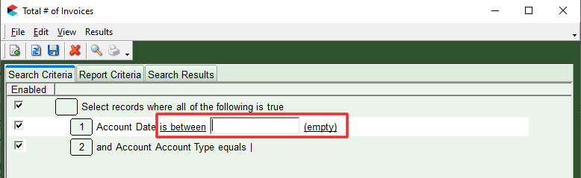

## Revenue by AAHA/VMG Chart of Accounts

This report will give you the revenue breakdown for all treatments and items that contain a Report Code using the recommendations on Chart of Accounts on pages 5 and 6.

search [Client] code 'VMGQRC20' name 'Quarterly Revenue by Category'

category 'VMG Quarterly Reports' (

  [Account-Date] is between '01-01-21' '03-31-21' and

  [Account] exists in (

    [Account-Treatment-Report Codes] does not equal '' or

    [Account-Item-Report Codes] does not equal ''

  )

) report (

  [Account-Amount] summary (sum),

  [Account-Recordable Entry-Report Codes]

) sort by (1 ascending) summarize by sort order

## Total Number of Patient Visits

You will need to use a Patient Check-In code (typically ‘Vi$it’ ) or have another exam code or consistent code entered when a patient is physically presented to the practice and seen by a veterinarian for a medical or surgical service or for a professional service ordered by a veterinarian during the quarterly reporting time period to utilize in the search. If the criteria just mentioned is not met, the search will not work. Medication purchases without the patient physically present are not included as a patient visit. It is imperative to train the hospital client service staff to accurately use the “Vi$it” patient check in code using the VMG criteria for a patient visit.

search [Client] code

'VMG00002' name 'Quarterly Patient Visits'

category 'VMG Quarterly Reports' (

[History-Code] equals 'Vi$it' and

[History-Date] is between '01-01-21' '03-31-21'

) report (

[History-Description] caption 'VISITS',

[History-Code] summary (count),

[History-Site]

) sort by (2 ascending, 0 ascending) summarize by sort order

## Revenue for Patients with Visits

This search will calculate the total revenue for the patients who were physically present in the practice and seen by a veterinarian for a medical or surgical service or for a professional service ordered by a veterinarian during the quarterly reporting time period. If a patient received a medication refill or other item was ordered by the veterinarian, but the patient was not physically present during the purchase, then that purchase should not count as a patient visit revenue for this calculation.

search [Client] code 'VMG00003' name 'Quarterly Revenue for patient visit'

category 'VMG Quarterly Reports' (

[History-Date] is between '01-01-21' '03-31-21' and

[Patient] exists in (

[History-Date] is between '01-01-21' '03-31-21' and

[History-Code] equals 'Vi$it'

)

) report (

[Client-Account],

[History-Amount] summary (sum),

[History-Site]

) sort by (2 ascending) summarize by sort order

## Number of Active Clients

Clients with any type of service or item in accounting in the time frame you choose.

search [Client] code 'VMG00004' name 'Active Clients - 24 Months'

category 'VMG Quarterly Reports' (

  [Account-Account Type] equals 's,t' and

  [Account-Date] is between '01-01-19' '12-31-21'

) report (

  [Account-Site],

  [Client-Account] summary (distinct)

) sort by (0 ascending) summarize by sort order

## Active Patients (by species) - Past 24 Months

search [Client] code 'VMG00005' name 'Active Patients by Species - 24 Months'

category 'VMG Quarterly Reports' (

  [Account-Date] is between '01-01-19' '12-31-21' and

  [Account-Account Type] equals 's,t'

) report (

  [Account-Site],

  [Account-Patient-Species Entry-Species],

  [Account-Patient-Record Number] summary (distinct)

) sort by (0 ascending, 1 ascending) summarize by sort order

## Quarterly New Clients

search [Client] code 'VMG00006' name 'Quarterly New Clients'

category 'VMG Quarterly Reports' (

  [Client] exists in (

    [Account-Account Type] does not equal 'b' and

    [Account-Date] is between '01-01-21' '03-31-21'

  ) and

  [Client] does not exist in (

    [Account-Date] is less than '12-31-20' and

    [Account-Account Type] does not equal 'b'

  )

) report (

  [Client-Account] summary (count),

  [Client-Full Name],

  [Client-Added]

) sort by (0 ascending)

# Quarterly Routine

The steps below will guide you through what you should be doing each quarter to gather the data needed for VMG Quarterly Reporting.

## Information Searches

1. Go to **Work with > Information Search**. Select the VMG Quarterly Reports Category.

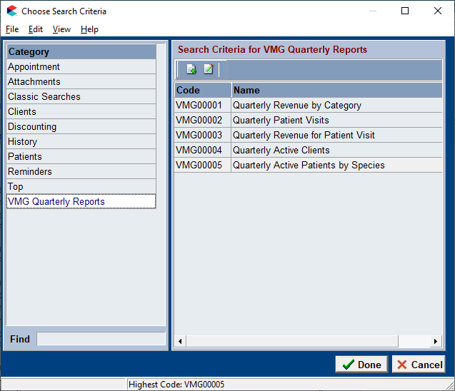

1. Open each search, VMG00001-VMG00006.
2. **Adjust the dates** to match the quarter that recently closed.
3. Click **Run** and transcribe the results into DATALink.

## Period Totals

1. Go to **Work with > Reports**.
2. Select the **Period** of **Quarter** and the **End** date of the last quarter.
3. Move the report, **Period Totals**, into the **Print These** column, and click **Print**.

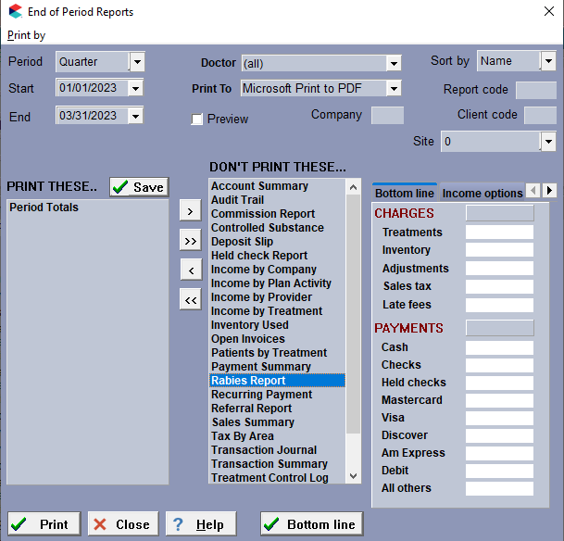

This report will help you find your Tax Information, Late Fees assessed, and Total Invoices.

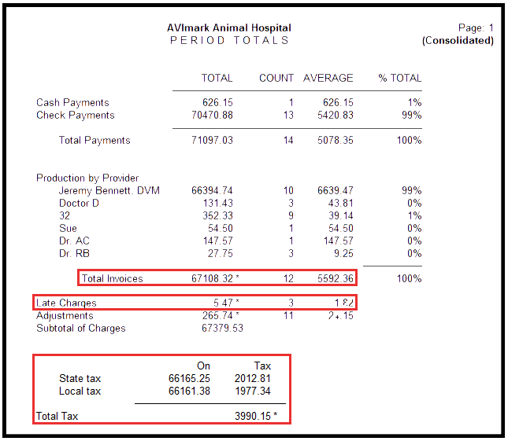

## Inventory Report

This report will help you find the total stock value to report for the quarter.

1. Go to **Work with > Inventory List**.
2. Click **File > Reports > Inventory Report**.
3. Check **Totals Only** and click **Print**.

|  |  |
| --- | --- |
|  | **For Covetrus ordering, look at** [**www.intelligentinventory.com**](http://www.intelligentinventory.com)**. Intelligent Inventory can help keep your on-hand and cost values accurate.** |

The Stock value column will display the total cost of the products you currently have on hand. This calculation is done by multiplying the on-hand quantity by the average cost of the item.

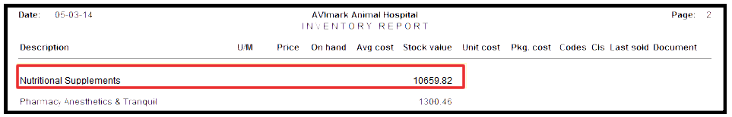

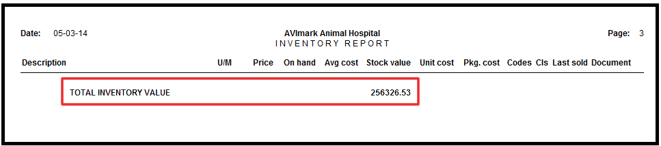

|  |  |
| --- | --- |
|  | **This report is ideal for reporting the total stock value of your inventory if you receive Purchase Orders through Avimark. If you do not have your inventory completely aligned categorically with the AAHA/VMG Chart of Accounts, please only use the “Total Inventory Value” line. If your inventory is categorized to match the AAHA/VMG Chart of Accounts, then you can use the Category Values, like the Nutritional Supplements line above.** |